1. Dashboard
   * 1. Show recommended tips
     2. Show last Files Printed (5, 10, 20) in All Printers or Specific with all details (have the ability to select on the top of the view)(with click go to real time log)
     3. Show title System Status: Online Printers, Printers Status, Total Coloured and BW pages printed today, Chart with printing volume of last week
     4. Shortcut’s for function set in option menu
2. Real time Log
   * 1. Show real time log for ALL printers or specific printer (ability to choose from the top of the page). Information for each job will be: date, time, Job Pages, Job selected pages to be print, Paper size, Colour pages, BW pages, Duplex, Cost for job
3. Printers
   * 1. Show all printers installed on computer with online status of each one
     2. Click on each printer to setup configuration for charging in each mode *(colour or bw, size A4 or A3, duplex, etc. This configuration must be locked and able to change only with password, maybe set by installation and able to change in options)*
     3. In list of printers also show total job each printer has printed and total paged by each colour mode
     4. Also shortcut for report for printers
4. Reports
   * 1. Select report
        1. By Printer or All Printers (select from the top maybe)

EACH REPORT MUST HAVE BE VERY FRIENDLY DESIGNED (I WILL PROVIDE THE PROTOTYPE DESIGN TO YOU)

ALL INFORMATION:

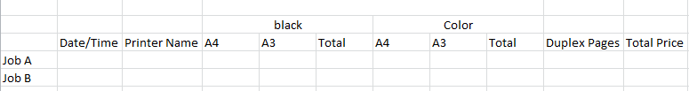

EXAMPLE

Set dates that want to view

* Total Jobs printed (file name)
* Name of job
* Date/Time
* Total Pages by colour mode printed (counter for A4 and for A3 for each BW & Colour) (reminding when printing **auto mode** the system must count depending the file colour)
* Total duplex pages printed *(when printing duplex mode reminding we count two pages for the total pages counter, Activate this feature in options)*
* Total charge per Job and total per selected period
* Have charts that will show above information
* On bottom of report sum all details

Able to export report in PDF or XLS

1. Options
   * 1. Select language (two option Greek and English)
     2. Select logo for business on App and on Reports (two options)
     3. Select shortcuts in dashboard
     4. Activate duplex count
     5. 2nd way to change charges of cost of printer
     6. Change password for configuration of charges
2. About
   * 1. Information for company and application